EE326 Homework #3
20210203 노욱진
November 04, 2025

- Step 1:
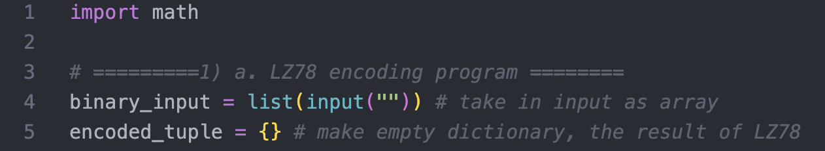
Import math for calculating compression rate. Take in the input as list of str. And declare “encoded_tuple” that stores string(key) and tuple(value) pair.

Step 2:
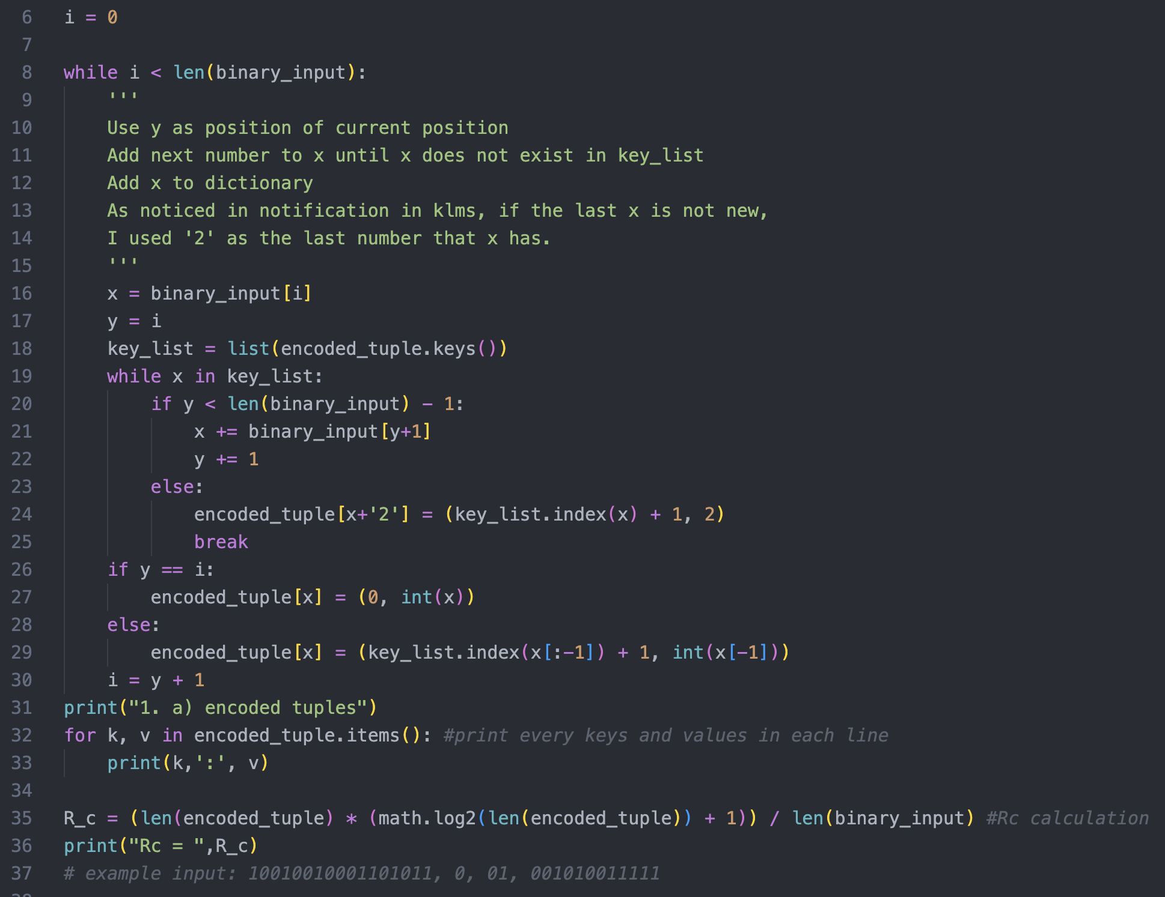
I used y as position of currently computing position in “binary_input”. Therefore, “i” starts from ‘0’ to ‘len(binary_input)-1’. From dictionary “encoded_tuple”, make “key_list” that contains only words. If string “x” is in “key_list”, add “x” next input and repeat this until “x” is not in “key_list”. If ‘len(x)’ is 1, add dictionary “x : (0, int(x))”. If not, add dictionary “x : (‘last word’s order’, int(x[-1])”. Because list start from 0 in python, I added ‘1’ to real order. After this, set “i” as ‘y+1’ and repeat. Then dictionary will be completed.
*As noticed in klms, if the sequence ends with a phrase that already exists in the current dictionary, treated this case by adding ‘2’ to the “x”.

Step 3:
Print every keys and values of “encoded_tuple” in each line. Also, calculate compression rate and print it.

- Step 1:
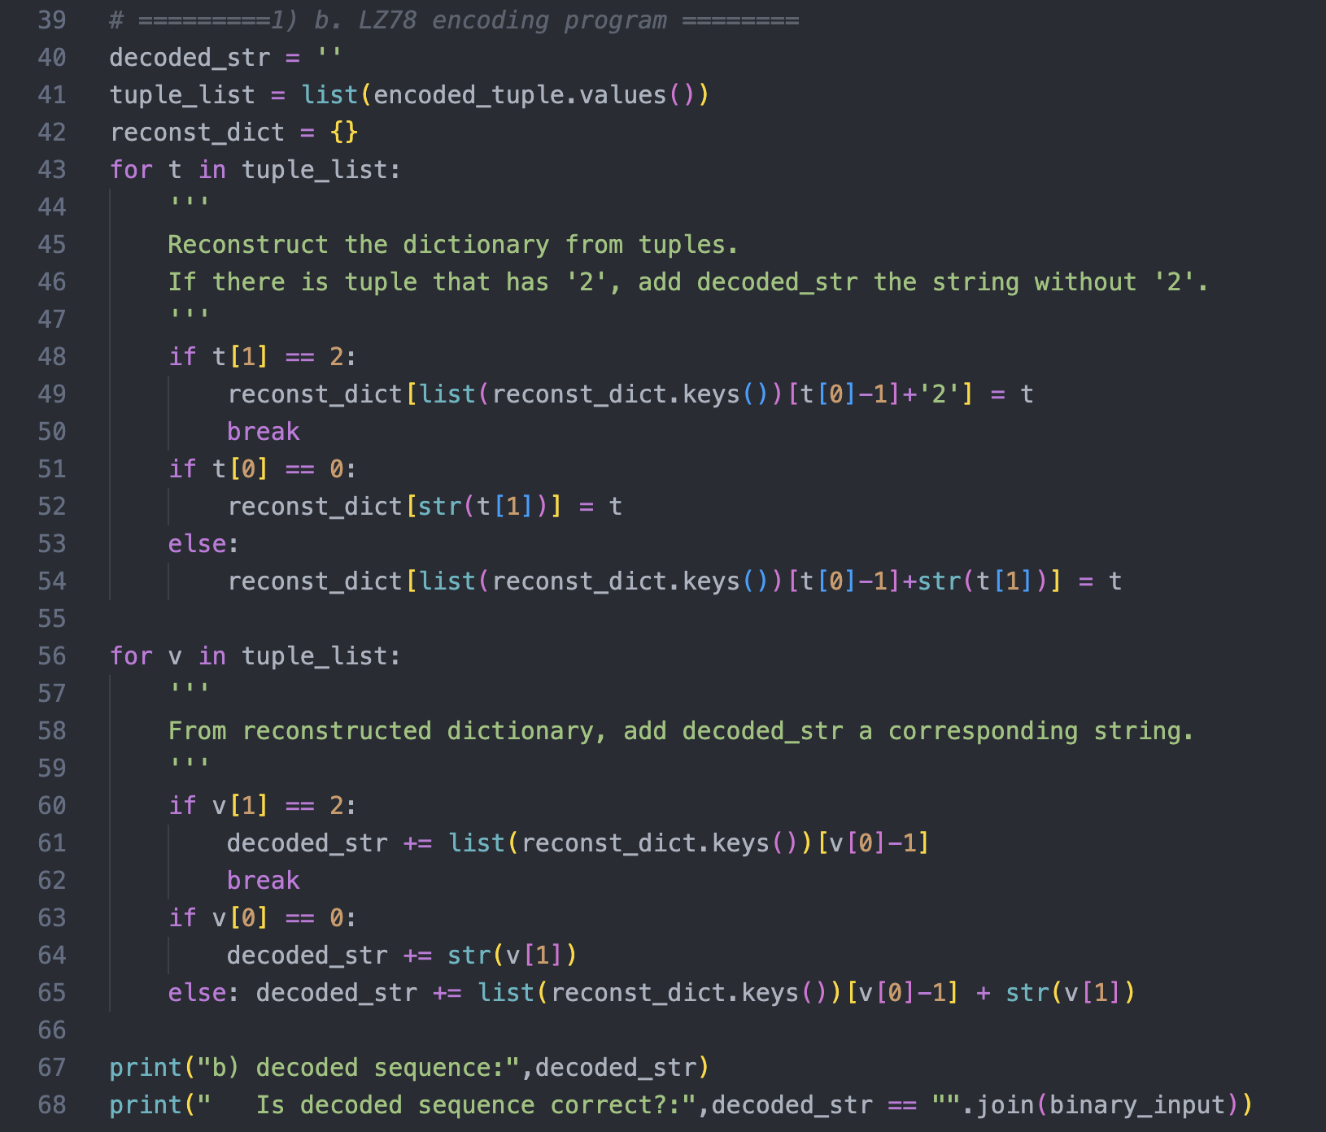
Make empty string that will be the sequence of decoded string. As we use only encoded tuples, take value part of “encoded_tuple”.

Step 2:
From “tuple_list”, reconstruct the dictionary treating ‘2’ as special case.

Step 3:
From “reconst_dict”, make decoded string using key values of “reconst_dict”. If tuple has ‘2’, add “decoded_str” without ‘2’

Step 4:
Print the result. Also, test if the decoded string is the same as original source.

- Step 1: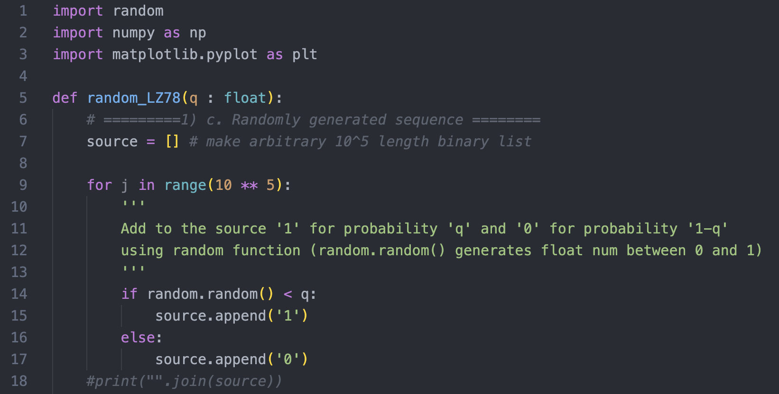
Imported random to implement probability ‘q’ and ‘1-q’. Using random.random() function, add ‘1’ to list “source” for probability ‘q’ and ‘0’ for probability ‘1-q’. And repeat this 10⁵ times. I implemented function “random_LZ78” in new python file to repeat encoding and decoding repeatedly.

- Simulation result:
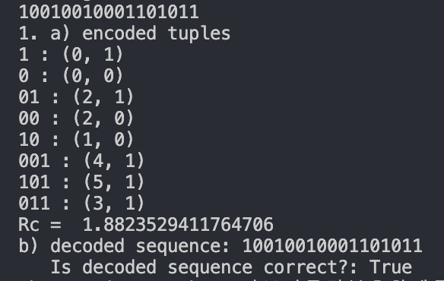
From “HW3_LZ78.py” and input “10010010001101011”, the result is the same as lecture.

- 
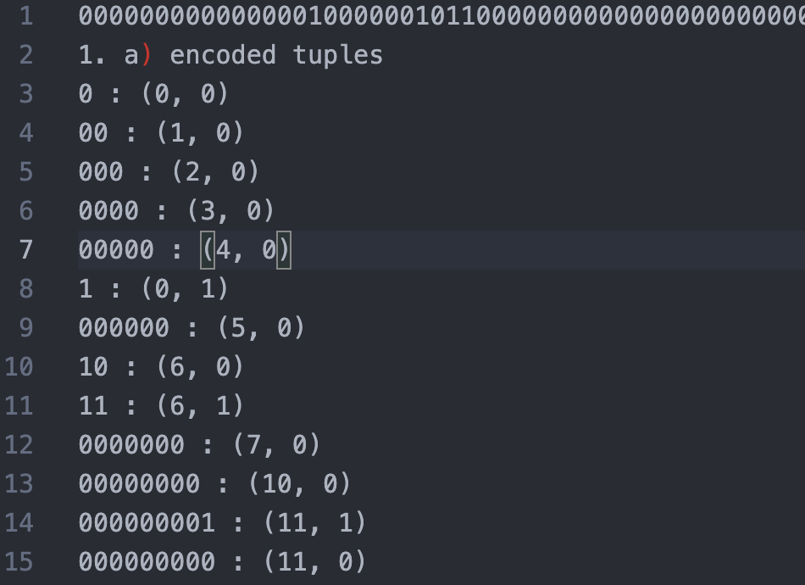
I’ll add txt file of simulation result on klms.

First line: generated lengh-10⁵ binary sequence with q=0.1
2-4759 line: encoded tuple
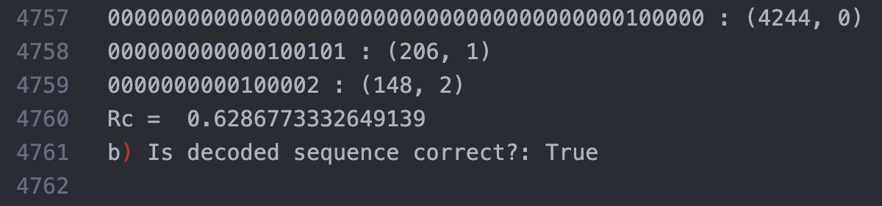
4760 line: compression rate
4761 line: comparison between original source and decoded sequence

- Using code underneath, I plotted H(q) and Rc(q) with ‘q’ from 0.02 to 0.3
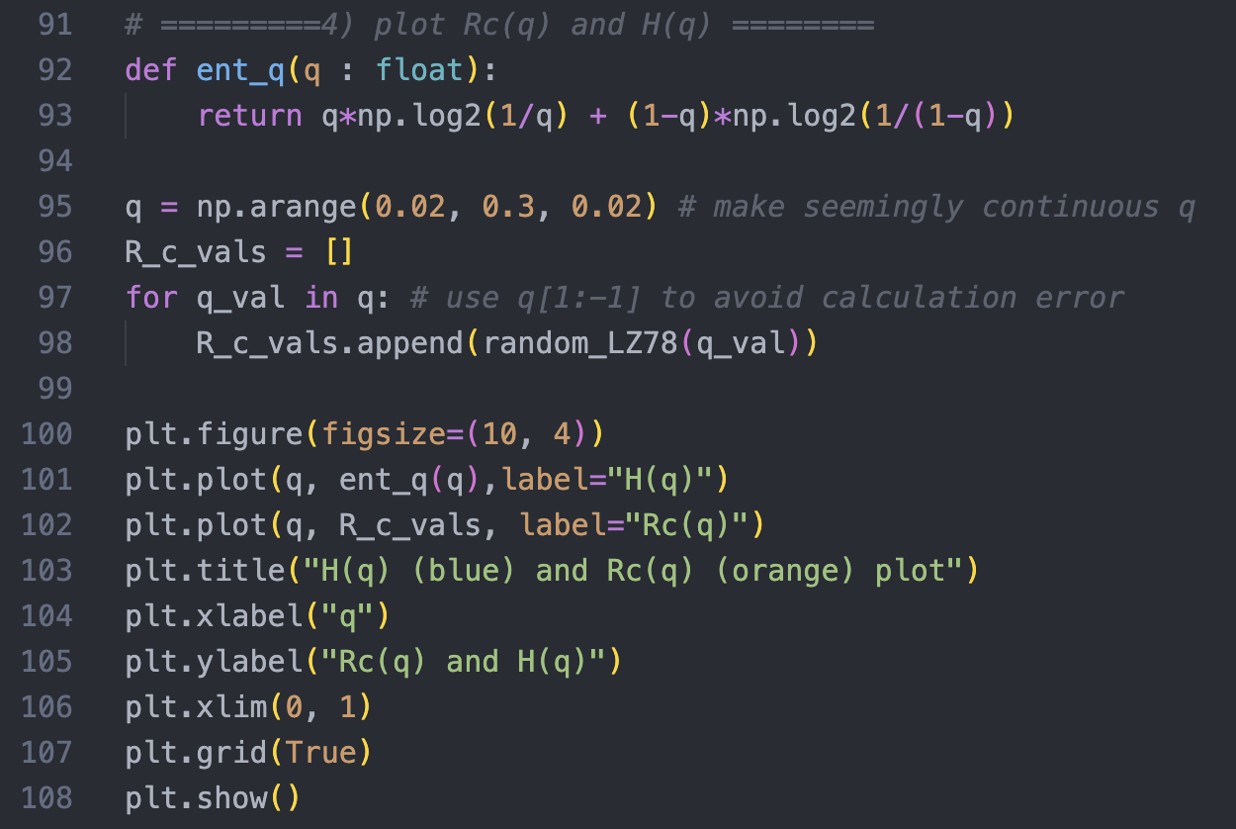
Simulation result:
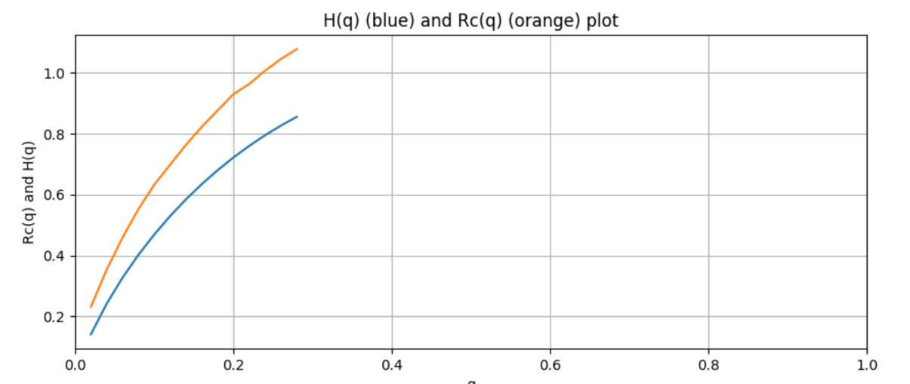
In simulation result, we can find out Rc(q) is always above H(q) (Rc(q) > H(q)). This clearly shows limit of compression, the entropy.
Also, H(q) value goes higher as ‘q’ becomes closer to 0.5 and same as Rc(q).

